**Product Requirement For ITU-SAT**

# **Intro & Goal**

Our goal is to make SAT, a mobile app which automated the attendance of students at ITU. This product will suppress the traditional method of marking attendance. It simplify and provide enhanced experience of tracking attendance using a cell phone. It will capture students attendance on two criteria- Student’s ID and Student’s current location at the ITU campus. SAT will reduce the hassle for professor and for students of missing the name or mispronouncing it.

# **Who’s** it for?

1. **ITU Students-** They can register themselves and then can give class attendance as per their enrollment in the courses. They can request for an attendance record at any instances.
2. **ITU Professors-** They can register themselves and then add their courses details. They can also request group or individual student attendance record at any instances.

# **Why** build it?

1. To simplify the process of taking attendance in class.
2. To reduce the hassle of professors as well as for students for missing the names or mispronunciations.
3. To keep a proper track of students attendance.
4. To automate the process which reduce the chance of errors to great extend.
5. To retrieve information of any student at any instance.

**What** is it?

## **Glossary**

1. **Home View** - homepage of SAT(all users can view this)
2. **Detailed View** - permalink page for each user
3. **Profile View** - registered user profile page

## 

## **User Types**

1. Registered Professors-
2. Registered Students-
3. Admin-

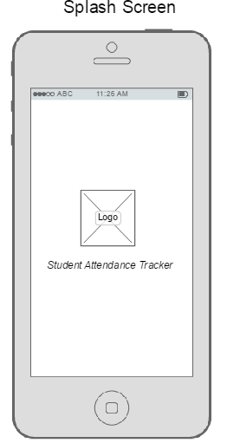

**Initial Splash Screen :**

* As the user starts SAT application , the splash Screen with SAT logo and Name Appears.

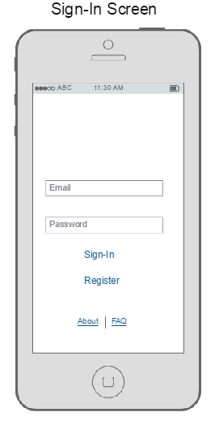

**Sign In /Register related link Page**

Already registered users **Signs-In**

* **Email Id :** ITU email ID
* **Password:** Min of 7 characters password

New User clicks on **Register**

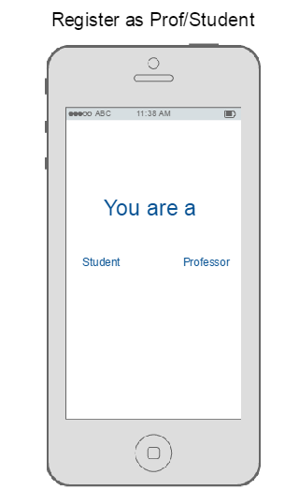

**Register Related link page**

* **Register as a professor**
* **Register as a student**

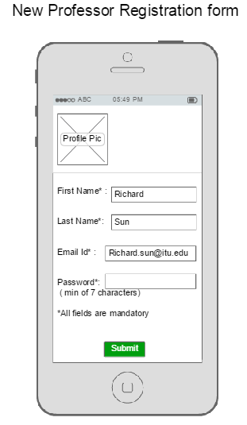

**Professor Registration Form Related Link Page**

* **First Name** - First name of the professor containing 20 characters in a text box. (Username will be the firstName)*
* **Last Name**- Last name of the professor containing 20 character in a text box.
* **Profile picture**- Picture of professor <image> (optional)
* **Email Id-** ITU Email address of professor in a text box <input type="email">
* **Password**- ITU password of professor in a text box <input type="password Min. of 7 characters">
* **Submit-** All details ofProfessor Registration Form Related Link Page<input type=”Submit” value=”submit”>
* **Push up-** Registration completed successfully.
* **Email Notification-** Once professor’s registration is completed, they receive an email notification “Your Registration successful at ITU-SAT”

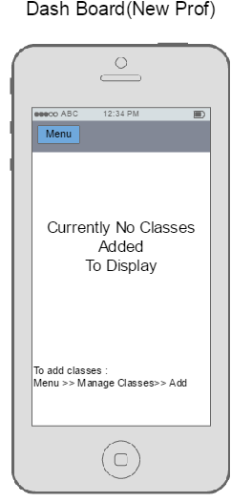

**New Professor DashBoard**

* As the Professor newly register, the dashboard remains blank
* Instructions for the professor on how to add classes

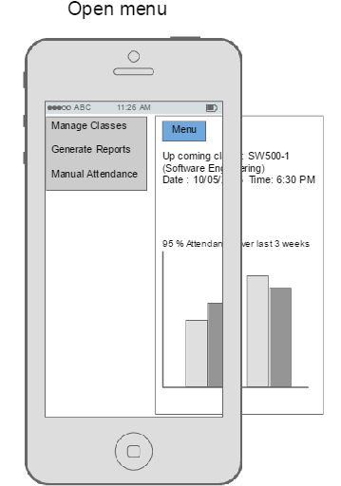

**Professor Dashboard/Home page (Already Existing)**

* **Menu -** Contains following options:

1> Manage Classes

2> Generate Reports

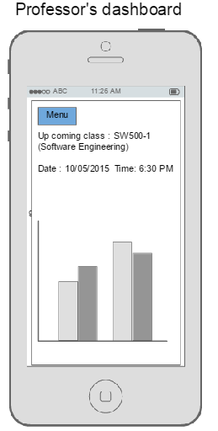 3> Manual Attendance

* **Nice To have Features:**

1>A message displaying the upcoming class along with date and timings

2> A graph that shows the total % of attendance for that particular upcoming class till date.

**Menu Option:**Sliding of Menu will push the dashboard view to side and will display the suboptions.

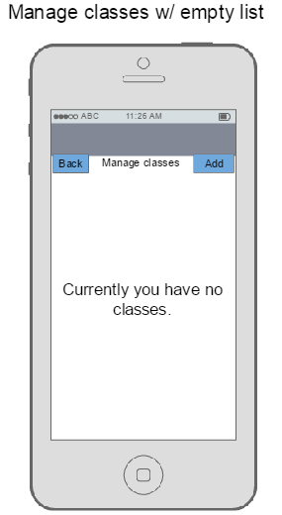

**Manage Classes (New Professor):**

* New Professor Manage class and Dashboard window will be blank initially , till he adds the courses/classes.

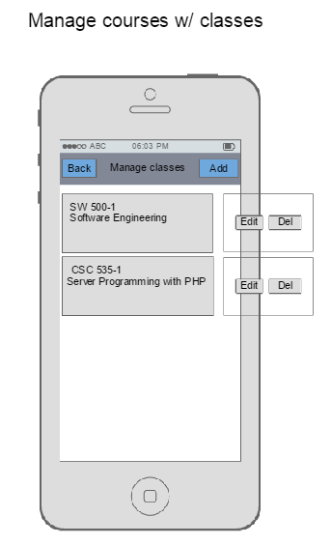

* **Manage Classes :** This option allows the professor to manage his classes. Following are the options available under this

1> **Add** : Professor can add the courses which he is going to take in the year

2> A list of already added classes by the professor with Edit and Delete option when swiped towards left.

3> **Back :** To go back to Menu page options

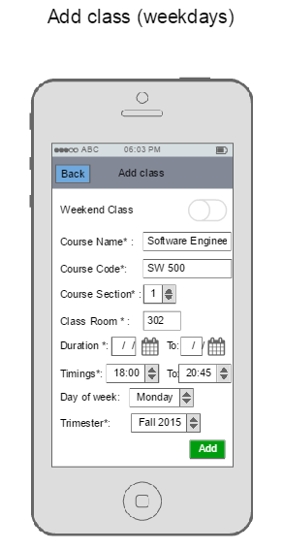

**Manage Classes >> Add Class (Weekday option selected)**

* **Switch Button :** To switch to **weekend** or **weekday** entry format based on class schedule
* **Course Name-** Full course name
* **Course Code-**
* **Section no-**
* **Location/ Class no’s-**
* **Time-**
* **Date-**
* **Day of the week -**
* **Current Trimester-**
* **Add & cancel option**
* **Push up notification-** Courses added successfully.

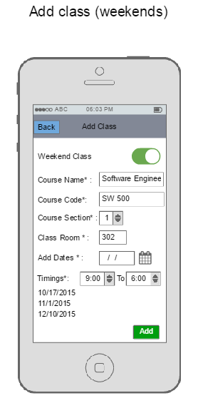

**Manage Classes >> Add Class (Weekend option selected)**

* **Switch Button :** To switch to **weekend** or **weekday** entry format based on class schedule
* **Course Name-** Full course name
* **Course Code-**
* **Section no-**
* **Location/ Class no’s-**
* **Time-**
* **Date-** To select multiple Dates
* **Current Trimester-\***
* **Add & Cancel option**
* **Push up notification-** Courses added successfully.

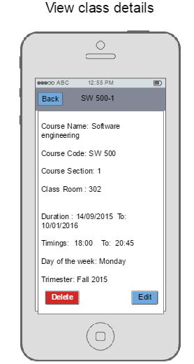

**Manage Classes >> Clicks on any of the subject name from the list**

* All the details of that subject which professor had entered during **Add class** appears.
* **Edit** - All the text bars appears so that professor can do necessary changes
* **Delete-** Deletes complete details of that particular class/course entry
* **Push up notification-** Specifying if the action was successful or not

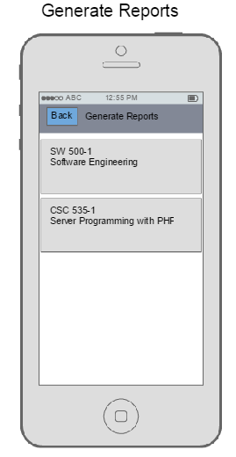

**Menu >> Generate Reports**

* Lists of all the classes/courses which the professor has added in the application.

Selecting any of the particular subject sends full class attendance report for that particular subject ,updated till date in Excel format to professor’s email Id.

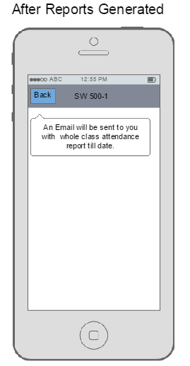

* **Push up notification :** Specifying an email was sent

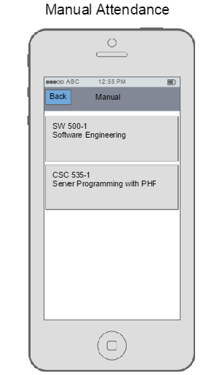

**Menu >> Manual Attendance**

* Lists of all the classes/courses which the professor has added in the application.

Selecting any of the particular subject, opens up a form where professor can manually mark attendance

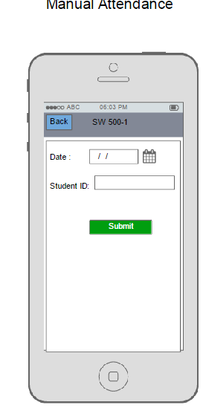

**Manual Attendance >> Clicks on any of the subject name from the list**

* **Date**- When the professor needs to mark the student’s attendance
* **Student ID**- Enter the Student Id
* **Push up notification-** Specifying that attendance was marked successfully and database updated.

**Registration Form for students Related link page**

**TAB 1 : Student Registration**

* **First Name** - First name of the professor containing 20 characters in a text box.
* **Last Name**- Last name of the professor containing 20 character in a text box.
* **ITU Student ID**- numeric 5 digits in text box
* **Profile picture**- Picture of professor <image> (optional)
* **Email Id-** ITU Email address of professor in a text box <input type="email">
* **submit :** Takes to next page or step

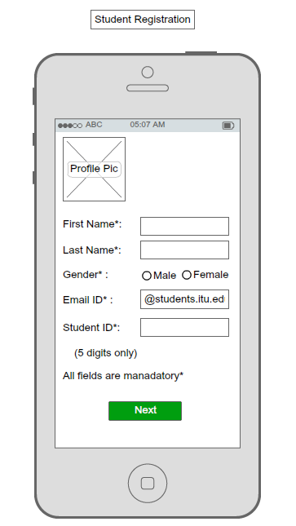

**TAB 3: Voice Sample**

* **Voice Sample**:Students to provide their voice sample (roughly 5-10sec)
* **Record:** click to record the voice
* **OK: (push up)Notification) voice sample recorded successfully**
* **submit : (Toast)Notification- Registration successful**

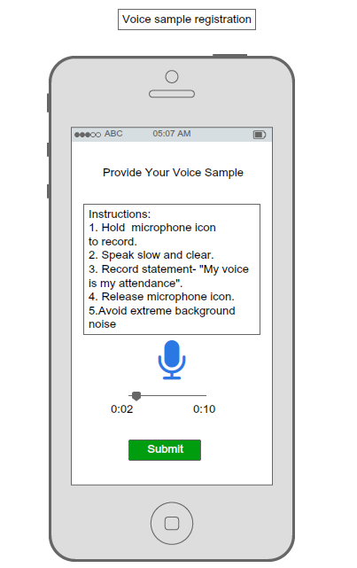

**TAB:3 Student Menu**

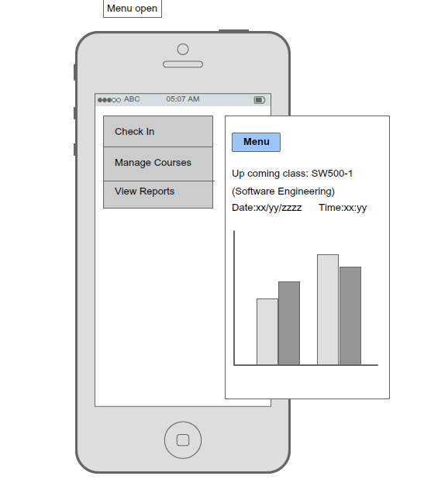

**TAB: 4 Check In**

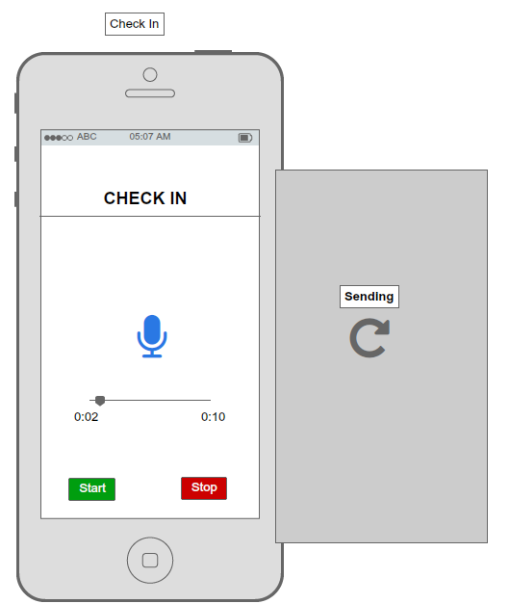

**TAB : Toast Notification ( Attendance Recorded Successfully)**

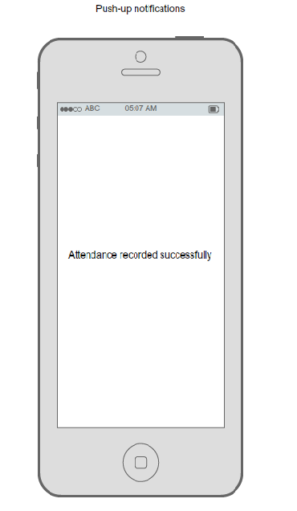

**TAB:5 Manage Courses**

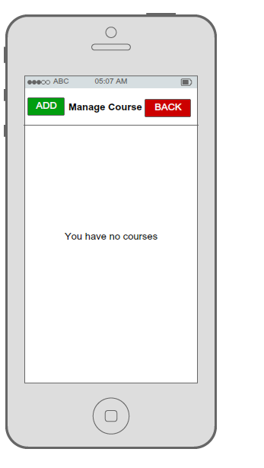

**TAB:6 Add Course**

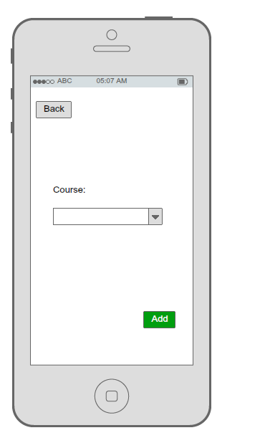

**TAB:7 List of added courses**

* **Course Code** :- Students to manually enter the Course code(subject name auto populates once code entered) and **Add button** next to it to add courses.
* **Submit** : Takes to next page or step vv

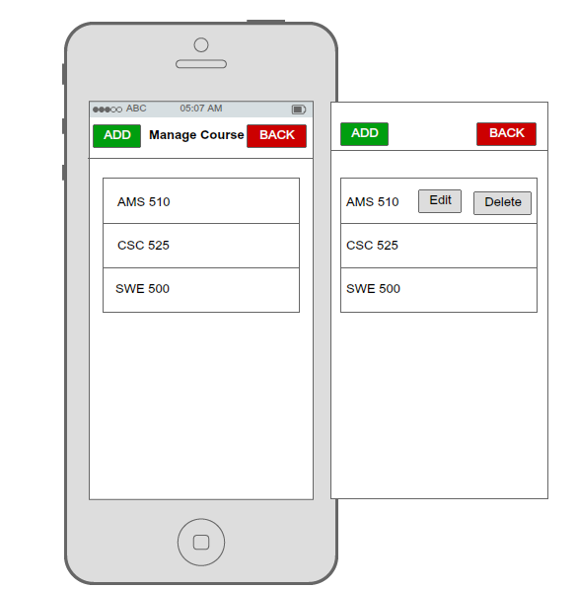

**TAB: 8 Student request attendance report**

